**Investigating the use of Mathematical models in Finance**

June 2023

Contents

1. Introduction……………………………………………………………pg 2
2. Theoretical objective of investigation
   1. Maximization of Portfolio returns function…………………… pg 3
   2. Minimization of Portfolio risk function……………………….. pg 5
3. Portfolio analysis
   1. Finding asset expected returns…………………………………pg 9
   2. Computing variance covariance Matrix………………………pg 12
   3. Constructing minimum variance frontier………………………pg 13
4. Evaluation of model
   1. Evaluation whether portfolio meets given objective and what to do in order to reach the objective………………………………………………………….pg 20
   2. Limitations of model…………………………………………pg 21
   3. Possibilities for modification/extension………………………pg 21
5. Conclusion……………………………………………………………pg 22

**Research Question:**

To find the maximum return that can be achieved from an investment with minimum risk using the Markowitz Portfolio optimization method.

1. **Introduction:**

I have always been fascinated by the working of the free market in our society. Living in a city like Bangalore (in Karnataka, India) seeing big tech offices every time you take a short drive down to the mall is a normal sight. My parents, being keen observers of the stock market, grumbling whenever stock prices fell and smiling gleefully when they rose was a schizophrenic sight. Companies could be doing well in the morning but suddenly do bad at night. Stock prices fluctuated so often that it made my head spin. the uncertainty involved with respect to earning money or losing it is enough to baffle most people. The refusal of the market to behave in an orderly manner makes the mathematics around it all the more interesting.

Harry Markowitz was an economics graduate student who devised a method to give an idea to potential investors, on how best they can earn with a given set of assets they want to invest in. Uncertainty and risk was quantified through measures such as standard deviation and variance. Return for an asset was referred to as ‘expected’ return. The word ‘expected’ is key for that it implies extrapolation. This is the essence of finance today. Through math we try to create a set of expectations about future returns through observations of historical returns on the basis that they follow some ‘pattern’. Some of these assumptions and patterns will be covered throughout the exploration and explained so as to how they are used to bring some structure to the unpredictability of the market. Ultimately, two terms matter. Expected return and risk. For an investor, his optimum portfolio may either want maximum return possible from a given amount of risk or minimum risk from a given amount of return. The Markowitz method uses several methods to calculate expected return, Risk and the optimum portfolio as per the investor. Some methods used stem from the statistical concepts of averages, Covariance, Standard deviation, normal distribution to Matrix Algebra and Lagrange multipliers.

Thus, my decision to choose this exploration stems from a desire to understand the existing methods of constructing a model which allows ordinary people to understand and invest in a system as uncertain as the market to meet their objectives. This will be done through using the portfolio of a close friend, who invested in the December of 2019. His investment decision will be analyzed **to find the maximum return his investment can achieve with minimum risk involved using the Markowitz portfolio optimization method.**

**2 - Theoretical objectives**

**2.1- Return maximization**

For any investment, the singular goal of the investor is to maximize expected return and minimize risk.

The word ‘expected’ does not denote in any sense the ‘desirable’ return in a portfolio, but what can be expected based on the current data at hand. The potential money earned from a portfolio depends on historical data which can give us an idea of what to expect. Thus, for us to find what the expected or anticipated return is, we must make use of the following expression for a portfolio of N asset, with I being each asset.

A **Portfolio** can be defined as a collection of financial investments for various assets such as stocks, bonds etc.

**Portfolio return** is the amount of money earned after investing in the portfolio

**Asset return** is the amount of money earned after investing in the individual asset

This is the formula for portfolio expected return[1]

Where

Wi= Weight of ith asset

$E\left(r_{i}\right)$ = asset expected return

The weight of an asset is the proportion of money spent on that particular asset from the total money spent on the portfolio which is represented by 1.

$\sum_{i=1}^{N}{}w_{i}=1$

The value of weights is a constant value based on the whims of the investor. He will change the amount of money he spends on each asset based on the configuration of weights which will grant him the maximum return. The Assets expected return, is one which is calculated through averaging the returns of an asset over a time period.

The following is the equation for asset expected return

$E(r_{i)}=\sum_{T=1}^{n}{}\frac{r_{it}}{n}$

Here, **n** is the number of years, months or days being considered as historical data to produce a value for expected asset return.

**rit**is the return of the stock per unit time, depending again on the time series used. The combined formula of the portfolio expected return is thus.

$E\left(r_{P}\right)=\sum_{i=1}^{N}{}w_{i }\left(\sum_{T=1}^{n}{}\frac{r_{it}}{n}\right)$

The dynamicity of stock prices requires investors to rely on finding the mean in order to have some idea of possible future returns. That’s why, the time series is often calculated either in months or sometimes even days to average out the uncertainties involved in stock returns.

The reason the mean is considered in such calculations is because stock returns are assumed to be normally distributed, where if there is a risk or standard deviation of values from its mean, it clusters around the mean. If normal distribution was not assumed, the use of mean returns would be invalid.

Thus, Investors will take a large time frame for the value of N to average out uncertainties. They can either take daily or monthly stock prices for up to 5 or 10 years

**2.2- Risk minimization**

The second essential component of Markowitz’s model is the calculation for risk, and the objective of the investor to minimize it.

In our lives, Risk is but the inherent uncertainty of future outcomes. In finance, it is exactly the same with the only change that the expected outcome is expected return. This uncertainty is nothing but standard deviation or variance for a set of values.

Variance of returns for an asset i=

${σ_{i}}^{2}=\frac{\sum_{i=1}^{N}{}{\left(\underline{r}-r_{it}\right)}^{2}}{N}$

${σ_{i}}^{2}=variance$

$\underline{r}=E(r_{i)}=asset expected return$

$r_{it}=return on i^{th}asset in t months after base year.$

when calculating the variance of a portfolio, we call it **portfolio variance (${σ_{P}}^{2})$**

The portfolio variance of a two-asset portfolio will be

[2]

If we were to acquire the equation for variance of a two-asset portfolio using matrices, the following is the derivation

${σ_{P}}^{2}= \left[w_{i} w_{j} \right]×\left[cov(r_{i,}r_{i}) cov(r_{i,}r_{j}) cov(r_{j,}r_{i}) cov(r_{j,}r_{j}) \right]×\left[w_{i} w_{j} \right]$

$=\left[w_{i} w_{j} \right]×\left[var(r_{i,}) cov(r_{i,}r_{j}) cov(r_{j,}r_{i}) var(r_{j}) \right]×\left[w_{i} w_{j} \right]$

Since the covariance of a random variable with itself is nothing but it’s variance

$=\left[w_{i}var\left(r_{i}\right)+w_{j}cov(r_{i,}r_{j}) w_{i}cov\left(r_{j,}r_{i}\right)+w_{j}var(r_{j}) \right]×\left[w_{i} w_{j} \right]$

Var ($r_{i}$)= ${σ_{i}}^{2}$ var ($r_{j,})$ = ${σ_{j}}^{2}$

= ${w_{i}}^{2}{σ_{i}}^{2}+ {w_{j}}^{2}{σ_{j}}^{2}+w_{i}w_{j} Cov\left(r_{i},r_{j}\right)+ w_{i}w_{j} Cov(r_{i},r_{j})$

To now generalize this equation for the variance of a multiple asset portfolio is as follows

= $\left[w_{1} … w_{n} \right]×\left[{σ_{1}}^{2} ⋯ {σ_{1}}^{2}{σ_{n}}^{2} ⋮ ⋱ ⋮ {σ_{n}}^{2}{σ_{1}}^{2} … {σ_{n}}^{2} \right]×\left[w_{1} ⋮ w_{n} \right]$

To calculate the covariances between the assets, the following formula can be used

Covariance of two assets at once=

$σ_{i}σ_{j}=\sum_{t=1}^{N}{}\left(\underline{r_{i}}-r_{it}\right)(\underline{r_{j}}-r_{jt})$

$σ_{i}σ_{j}=covariance of i and j$

${\underline{r}}_{i}=expected return on asset i$

From this generalization, the covariance matrix can be calculated using stock prices. For the return function, asset expected returns can be calculated through stock prices. What remains a variable is the weights. This is the case since the amount of money spent on whichever stock must be optimal i.e giving the best return with lowest risk. To determine the optimal weights, the variance function must be minimized with all constraints involved. Thus**, the exploration will seek to find these optimal weights**. After calculating the weights, the process shall be repeated for multiple values of desired return in order to construct what is called a ‘**minimum variance frontier’.** This is a graph which can be used to evaluate an optimal investment (high return, low risk). Thus, what we are looking for is efficient investment (lowest possible risk) for any given amount of expected return.

The use of matrices helps in condensing the often-long calculations that arise in portfolios with multiple assets (at least 10 or 20). The generalization for variance holds true for as many number of assets with all the corresponding values of covariance computed.

Covariance in this context is nothing but correlation. It shows whether the movement in prices of two or more stocks follow a direct or inverse relationship. If a positive covariance exists between two stocks, the increase in price of one will coincide with the increase in price of the other. What is thus seen in the equation is that if the positive covariance between selected assets are high, there is greater variance or risk.

The goal of an investor is to reduce the variance of his portfolio which can thus be done with mixing assets which have high, low and negative covariance.

Covariance is calculated using historical stock price returns, and more the information the better. This is another reason stock price data is taken on a daily or monthly basis, linking back to the asset expected return function, where we specify a time frame that has many data points.

**3- Portfolio analysis**

Now that we have specified to some degree the theory behind the process, we will jump into the practical applicability of it with respect to the portfolio of a close friend. Table 1 consists of his investment portfolio.

**Table 1 (investment portfolio)**

| Assets | Weights (out of 100%) |
| --- | --- |
| 1. Aarti drugs (i) | 13% |
| 1. Ambuja cements (j) | 14.3% |
| 1. Britannia (k) | 9.9% |
| 1. Dabur (l) | 12.8% |
| 1. Dhanuka Agritech (m) | 14.8% |
| 1. Escorts (n) | 11.5% |
| 1. Muthoot Finance (o) | 11.2% |
| 1. Yes Bank (p) | 12.5% |

these are all stocks of prominent companies in India. When deciding his investment, my friend chose to look at the annual returns of these companies for the past 5 years and then invested. Doing so around December of 2019.

I will thus use the theoretical process described to evaluate the quality of his investment. For the purpose of calculation, one letter each will be assigned to the assets.

Example

k= Britannia stock

$r_{k}=return for asset k$

To find expected returns and Variance, we must first ensure all the data needed is computed.

To Find Portfolio expected return, we need the asset expected returns for each asset which is nothing but the annual returns.

To find the Portfolio Variance we need the variance-covariance matrix.

* 1. **Computing Asset expected return**

First, we need to compute the returns for all 8 assets in the portfolio. To do so, we need the historical data for stock prices with respect to the 8 stocks from 01-12-2014 to 01-12-2019. The following was retrieved using the website Yahoo Finance. The stock prices are taken monthly, thus yielding 60 months’ worth of monthly stock prices shown in table 2.

**Table 2 (historical monthly prices of stocks from 1st December 2015 to 1st December 2019)**

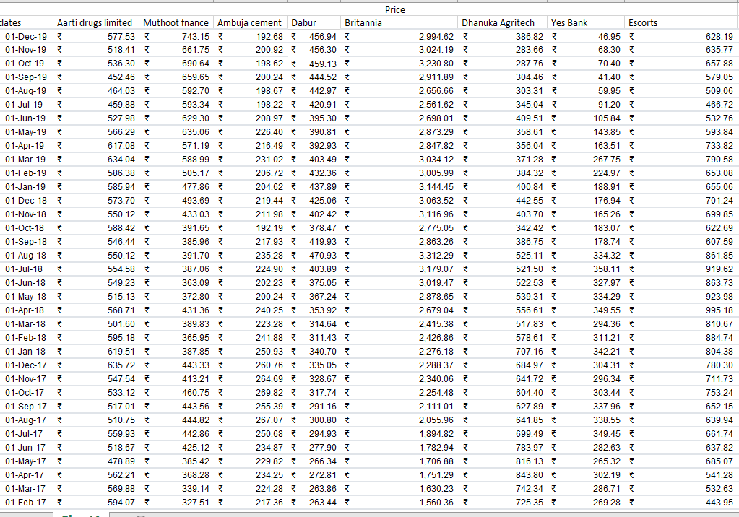

After the historical prices for each stock has been achieved, we calculate the returns for each stock per month from 1st December 2019 to 1st January 2015. The following formula is used

$r_{t}= lnln \left(\frac{P_{(t+1)}}{P_{t}}\right)$

t= time in months from 1st December 2014

Pt= monthly price of stocks

This formula can be generalized to all 8 assets of the portfolio

${ (r}_{ti}….r_{tp})=lnln \left(\frac{P_{t(i…p)+1}}{P_{t(i…p)}}\right)$ =

$r_{ti}=lnln \left(\frac{P_{59i}+1}{P_{59i}}\right)$

$r_{tj}=lnln \left(\frac{P_{59j}+1}{P_{59j}}\right)$

$r_{i}=return for asset i (Aarti Drugs)$

And so on.

The range of the variable of time is from 1<t<60.

It is till 59 (despite there being 60 stock prices) since if it was 60, the formula would not work out since there is no stock price value below December 2014 which makes 5 years or 60 months.

The of logarithmic returns over the standard formula $\frac{P_{(t+1)}-P_{t}}{P_{t}}$ is because logarithmic returns are what is called ‘Time consistent’ or ‘time additive’. This means that the returns on the first and last price on the stock, based on the limit of the time range, are the same as the summation of all returns in between the time period.

$lnln \left(\frac{P_{i1}}{P_{i61}}\right)=\sum_{t=1}^{60}{}lnln \left(\frac{P_{i(59+1)}}{P_{i59}}\right)$

in the case of the portfolio’s assets, the following holds true

For Aarti drugs limited=

$lnln \left(\frac{577.53}{380.27}\right)=lnln \left(\frac{577.53}{518.41}\right)+lnln \left(\frac{518.41}{536.3}\right) ….=41.79\%$

The same goes for the remaining assets. This mirrors that throughout the timeline, the average increase in returns is represented accurately and consistently through log returns, with respect to the two formulas for average return of the whole time set and the total of all individual average returns in the time set as shown in table 3.

**Table 3 (monthly returns for stocks from December 2014 to December 2019)**

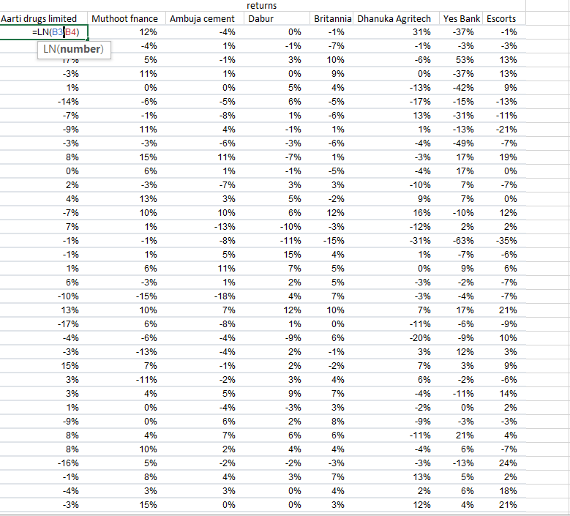

Next we must calculate the asset expected return which is nothing but the average of all returns for each individual asset.

$E(r_{i)}=\sum_{T=1}^{60}{}\frac{r_{it}}{60}$

The problem is however that these returns are represented in percentage. Thus, instead of conventionally dividing the sum of all returns with the number of months of data taken, we must follow a different approach.

First, we calculate total return and then divide it by 60. Now total return is not the summation of monthly returns but is the following

Total returns= T(p)= $\frac{P_{1}-P_{61}}{P_{61}}×100$

Average monthly returns=A(p)= $\frac{\frac{P_{1}-P_{61}}{P_{61}}}{60}×100$

Thus, we get the value for average monthly returns, which we have to convert to annualized returns, for the reason that we are considering 5 years’ worth of data and not 5 months, and thus annualized returns is a required measure. To do this, we need only multiply the average monthly return with 12. This must be done for all 8 assets

So now we have the 8 values for $E(r_{i…p})$ needed in the equation for expected returns which is denoted as Average Annual Return in the spreadsheet as seen in table 4.

**Table 4 (values for average annual return or asset expected return)**

(i) (j) (k) (l) (m) (n) (o) (p)



Since these values are used with the assumption of normally distributed stock returns, there can be a problem with respect to accurately using these values to predict returns since stock returns in the market need not be normally distributed.

* 1. **Computing Variance-Covariance Matrix**

Now to find our Portfolio Variance, according to the formula we need the weights for each stock and the Variance-Covariance matrix.

What we thus need to calculate now is the variance-covariance matrix for all 8 stocks.

As discussed before, Matrix Algebra plays a very beneficial role since it removes the arduous task of noting down the variance or standard deviation of a massive portfolios (20-30 assets), which involve several covariance values and weights. As covariance is used in the formula for portfolio variance, the covariance matrix plays a unique role of generalizing for multi -asset portfolios. Otherwise, Covariance matrices are used to determine the errors in the statistical concept of estimators.

Since we have an eight-asset portfolio, the covariance matrix of the portfolio is the following

**Key= ${σ_{ij}}^{2}$ = covariance of i and j = ${σ_{j}}^{2}{σ_{i}}^{2}$**

i j k l m n o p

$\left[{σ_{i}}^{2} {σ_{ji}}^{2} {σ_{ki}}^{2} {σ_{ij}}^{2} {σ_{j}}^{2} {σ_{kj}}^{2} {σ_{ik}}^{2} {σ_{jk}}^{2} {σ_{k}}^{2} {σ_{li}}^{2} {σ_{lj}}^{2} {σ_{lk}}^{2} {σ_{il}}^{2} {σ_{im}}^{2} {σ_{in}}^{2} {σ_{io}}^{2} {σ_{ip}}^{2} {σ_{jl}}^{2} {σ_{kl}}^{2} {σ_{l}}^{2} {σ_{jm}}^{2} {σ_{km}}^{2} {σ_{lm}}^{2} {σ_{jn}}^{2} {σ_{jo}}^{2} {σ_{jp}}^{2} {σ_{kn}}^{2} {σ_{ko}}^{2} {σ_{kp}}^{2} {σ_{ln}}^{2} {σ_{lo}}^{2} {σ_{lp}}^{2} {σ_{mi}}^{2} {σ_{mj}}^{2} {σ_{mk}}^{2} {σ_{ni}}^{2} {σ_{nj}}^{2} {σ_{nk}}^{2} {σ_{ml}}^{2} {σ_{m}}^{2} {σ_{mn}}^{2} {σ_{mo}}^{2} {σ_{mp}}^{2} {σ_{nl}}^{2} {σ_{nm}}^{2} {σ_{n}}^{2} {σ_{no}}^{2} {σ_{np}}^{2} {σ_{oi}}^{2} {σ_{oj}}^{2} {σ_{ok}}^{2} {σ_{pi}}^{2} {σ_{pj}}^{2} {σ_{pk}}^{2} {σ_{ol}}^{2} {σ_{om}}^{2} {σ_{on}}^{2} {σ_{o}}^{2} {σ_{op}}^{2} {σ_{pl}}^{2} {σ_{pm}}^{2} {σ_{pn}}^{2} {σ_{po}}^{2} {σ_{p}}^{2} \right]$

The numeric values are shown in table 5

**Table 5 (numeric values of covariance matrix)**

i j k l m n o p

| | 0.121611 | 0.026404 | 0.01514 | 0.010993 | -0.02659 | 0.000568 | -0.02311 | 0.031266 | | --- | --- | --- | --- | --- | --- | --- | --- | | 0.026404 | 0.095705 | 0.045855 | -0.01278 | -0.01278 | 0.042877 | -0.02483 | 0.050032 | | 0.01514 | 0.045855 | 0.059524 | 0.019898 | 0.025081 | 0.025081 | 0.027846 | 0.003347 | | 0.010993 | 0.017349 | 0.019898 | 0.035823 | 0.005611 | 0.022012 | 0.005657 | 0.012709 | | -0.02659 | -0.01278 | 0.006515 | 0.005611 | 0.213432 | -0.00446 | 0.42734 | 0.088214 | | 0.000568 | 0.042877 | 0.025081 | 0.022012 | -0.00446 | 0.135378 | -0.01472 | 0.020497 | | -0.02311 | -0.02483 | 0.027846 | 0.005657 | 0.42734 | -0.01472 | 1.273624 | 0.202221 | | 0.031266 | 0.050032 | 0.04016 | 0.012709 | 0.088214 | 0.020497 | 0.202221 | 0.192833 | |
| --- | --- | --- | --- | --- | --- | --- | --- | --- | --- | --- | --- | --- | --- | --- | --- | --- | --- | --- | --- | --- | --- | --- | --- | --- | --- | --- | --- | --- | --- | --- | --- | --- | --- | --- | --- | --- | --- | --- | --- | --- | --- | --- | --- | --- | --- | --- | --- | --- | --- | --- | --- | --- | --- | --- | --- | --- | --- | --- | --- | --- | --- | --- | --- | --- |

For the sake of accuracy and since calculations are done on excel, the entirety of the values will be taken for accuracy without rounding the values off to any fixed number of significant figures.

* 1. **Constructing minimum variance frontier**

With the following information at hand, we will now be able to calculate the expected return and variance for the portfolio in order to determine the best possible investment which minimizes risk for a given amount of return.

To calculate expected return, we use the following formula as mentioned:

$E\left(r_{P}\right)=\sum_{i=1}^{N}{}w_{i}E\left(r_{i}\right)$

To calculate the following using excel, we use Matrix multiplication to reduce time spent on the calculation. Note, that the goal is to find the optimum weights, so the weights are still variable.

$E\left(r_{P}\right)=\left(w_{i} … w_{p} \right)\left[10\% ⋮ 80\% \right]$

For calculating variance, we use the formula as mentioned

$\left[w_{i} … w_{p} \right]×\left[0.121611 ⋯ 0.031266 ⋮ ⋱ ⋮ 0.031266 … 0.192833 \right]×\left[w_{i} ⋮ w_{p} \right]$

Now we have two parameters required for the purpose of optimization. The goal, as mentioned, is the minimization of risk for a given expected return. This must be done through entering the relevant information in a Lagrangian function.

Lagrange functions are used because there are multiple variables involved in the calculation (8 weights) thus making it a multivariable equation. To find the maximum and minimum of such equations along with certain constraint or conditions the equation is bound to can be done using the Lagrange method.

First, we need the function for Variance in non-matrix form for all 8 assets which is the following

${σ_{P}}^{2}= \sum_{i=1}^{n}{}⋯\sum_{p=1}^{n}{}w_{i}….w_{p}×σ_{i}σ_{j}….σ_{o}σ_{p}$

$w_{i}….w_{p}×σ_{i}σ_{j}….σ_{o}σ_{p}= w_{i}$

The variance function is what we will call the objective function[3]. Thus, with this in hand let us set the constraints for the optimization function. The first constraint will involve any desirable return for the portfolio. Thus, when the expected return of the portfolio is equal to the desired return of the investor the condition is met. In other words, the expected return – desired return=0.

1st constraint= $\sum_{i=1}^{n}{}w_{i}….w_{p}×E\left(r_{i}…..r_{p}\right)-d=0$

Where d= desired return

The second constraint is one which states that the addition of all portfolio weights W should add up to 1.

2nd constraint= $λ_{2}$ = $\sum_{i=1}^{N}{}w_{i}….w_{p}-1=$ 0

Now that we have both constraints in place, we can combine the constraints and the objective function to get the Lagrangian function. In this function, the constraints will we added through inserting Lambda, which acts as the lagrangian multiplier.

$Y=\sum_{i=1}^{n}{}×⋯\sum_{p=1}^{n}{}w_{i}….w_{p}×σ_{i}σ_{j}….σ_{o}σ_{p}+λ_{1}\left(\sum_{i=1}^{n}{}w_{i}….w_{p}×E\left(r_{i}…..r_{p}\right)-d=0\right)+λ_{2}\left(\sum_{i=1}^{N}{}w_{i}….w_{p}-1=0\right)$

Now, we take the partial derivatives for Y w.r.t all weights staring from $w_{i}$ along with the partial derivative for the constraints Y w.r.t Lambda. Partial derivatives are taken for the objective function of variance with respect to each weight to isolate the relationship between variance and the 8 weights. This allows us to factor in the impact on variance when weights change along with the two constraints.

$\frac{∂Y}{∂w_{i}}=0 where i=1 to n$

$\frac{∂Y}{∂w_{i}}=2w_{i}σ_{ii}+2w_{j}σ_{ij}+2w_{k}σ_{ik}+2w_{l}σ_{il}+2w_{m}σ_{im}+2w_{n}σ_{in}+2w_{0}σ_{io}+2w_{P}σ_{iP}+λ_{1}E\left(r_{i}\right)+λ_{2}=0$

Like this, the partial derivative must be found for all weights, from Wi to Wp.

.

**Now we must determine weight vectors which are needed to understand the optimal weights of the portfolio.**

For this, we must multiply two matrices **C** and **x**.

**C**= consists of coefficients of the partial derivatives of all weights, including the coefficients of weights from the partial derivatives of $λ_{1}$ and $λ_{2}$.

$C=\left[2σ_{ii} 2σ_{ij} ⋯ 2σ_{ip} E(r_{i}) 1 2σ_{ji} 2σ_{jj} ⋯ 2σ_{pj} E(r_{j}) 1 ⋮ 1 E(r_{i}) ⋮ 1 E(r_{j}) ⋮ ⋯ ⋯ ⋮ 1 E(r_{p}) ⋮ ⋮ 0 0 0 0 \right]$

Rows=10

Columns=10

**x**= consists of the weight components for each partial derivative equation and lambda. This is done since weights are variable, and the purpose of the investigation is to find optimum weights.

Matrix **x**= $\left[W_{i} W_{j} ⋮ W_{p} λ_{1} λ_{2} \right]$

Rows=10

Columns=1

Therefore

$c×x=k$

$\left[2×0.121 2×0.0264 ⋯ 2×0.0313 10\% 1 2×0.0264 2×0.0957 ⋯ 2×0.05 70\% 1 ⋮ 1 10\% ⋮ 1 70\% ⋮ ⋯ ⋯ ⋮ 1 80\% ⋮ ⋮ 0 0 0 0 \right]×\left[W_{i} W_{j} ⋮ W_{p} λ_{1} λ_{2} \right]=\left[0 0 ⋮ 0 d 1 \right]$

Since it is the weights that must be found, we must take the inverse of the equation

$C^{-1}Cx=C^{-1}k$

$x=C^{-1}k$

The calculation done for identity matrix of w will yield the following result

$w_{i}=a+b_{1}d$

$w_{j}=a+b_{2}d$

And so on for all weights i, j, k, l, m, n, o, p

Here, w will be our optimum weight such that for any desired return d, the risk/variance is minimum.

The following are the calculations.

The C matrix is as follows in table 6

**Table 6 (done in MS Excel)** 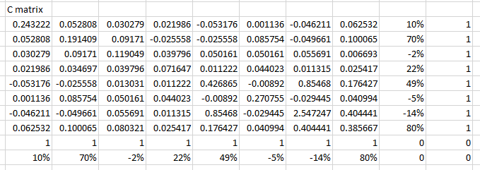

The C inverse matrix is as follows in table 7

**Table 7 (done is MS Excel)**

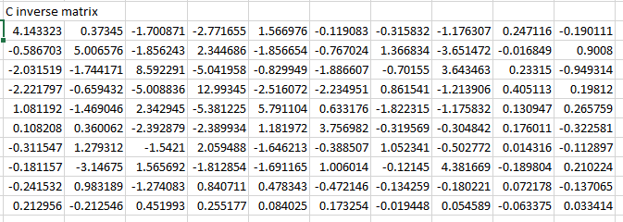

Thus, when multiplying the c inverse matrix with the matrix k, we get the following equations.

$W_{i}=0.247-0.190D$

$W_{j}=-0.017+0.9D$

$W_{k}=0.233-0.949D$

$W_{l}=0.405+0.198D$

$W_{m}=0.131+0.266D$

$W_{n}=0.176-0.323D$

$W_{o}=0.014-0.113D$

$W_{p}=-0.189+0.210D$

Now to find the optimal weights, a range of values for desired return (D) must be considered. The values of D were taken to be multiples of 5 to cover a wide range of possible returns

D= 5% ,10%.......65%

13 values of D

13 is thus also the value of n for the summation functions above in the lagrangian function.

Thus, substituting each value of D in each equation we get the following order of optimal weights. This was done using the excel solver for interest of time. The values are shown in table 8. For the purpose of accuracy, these weights are represented in raw decimal form instead of in percentage.

**Table 8 (list of optimum weights for desired return 5%,10%...65% using MS Excel)**

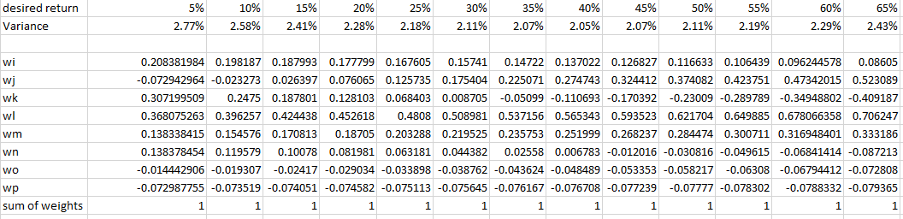

We encounter here, the peculiar case of negative weights. This is possible in finance for the following reason. What negative weights mean, is that instead of buying the stock using 5% of total investment money (for example) you must **Short the stock** which is borrow the stock wherein you don’t pay for it. What happens here, is that after borrowing you can sell the stock to someone else at it’s given price. When the price of this stock falls in the future you can buy it back and return it to the market (from where you borrowed) thus you return the borrowed stock and make extra money. This is done when people expect future stock prices to fall.

If we had to plot the points for desired return and Variance, graph 2 portrays the efficient frontier.

**Graph 1: minimum Variance frontier (graphed in MS Excel)**

This graph shows that for a specific amount of risk, there can be two values of expected return. This graph allows us to evaluate the maximum return we can get from a given amount of risk. Thus, my friends portfolio investment will be evaluated through where it falls in this graph, and whether his weights allowed had minimum risk for whatever amount of expected return he was aiming for.

**4- Evaluating model**

**4.1 Evaluating whether portfolio meets given objective and how to meet objective**

Based on the given data, if the investor had invested his money with the weights used, the following would be the return and risk and shown by Table 9. **Table 9: real weights used for investment (MS Excel)**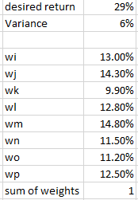

The return he would have received is 29% of the investment with a risk of 6%. This is not an efficient investment, as if we had to look for the variance of expected return 29% on the efficient frontier, the risk is about 2.12% (much lesser than 6).

Thus, the weights that should have been used for a return of 29% is shown in table 10.

**Table 10: Optimal weights that should have been used for investment (From MS Excel)**

As we can see, a much lower risk was available for the same desired return. This would have led to less volatility and greater returns than the previous investment whose risk is much higher.

However, if the best possible investment was desired, a desired return of 65% would give much higher returns for my friend along with marginally larger risk at 2.43% which would have been completely ideal and a more rewarding investment than the one he had done.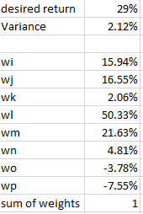

**4.2 limitations of model**

The accuracy of this evaluation can be challenged due to some assumptions made concerning the process. The assumption of asset returns being normally distributed was one which may make the computed optimal weights suboptimal. Instead of normal returns, stocks tend to follow fat-tailed distributions or highly skewed normal distribution curves which weren’t factored in. The assumption of stable correlation which states that the covariance between assets in the portfolio is constant over a period of time may also not be the case. This is because the correlation between asset returns depend on changes in the market which can very much occur drastically-as is occurring now during the pandemic-. Moreover, as seen in table 8, the model defines the requirements for optimal investment in very theoretical terms. This is seen through weights consisting of several decimal places (up to 10 or more) which can lead to impractical values of the amount of money required to invest. For example, taking the weight of 0.208381884 for an investment of 10,000 rupees is 2083.81984 rupees. It is not possible to invest exactly 0.81984 rupees or 81.984 paisa. (100 paisa=1 rupee).

**4.3 Possibilities for modification/extension**

Since the assumption of normality is a problem, there must be some way to calculate the amount of inaccuracy between the theoretical assumption of normality and the real distribution of stock returns. This value may help give better information to the investor by factoring in additional risk. This can be done using the Kolmogorov-Smirnov test which shows the difference between two distributions (theoretical and real in our case). Moreover, to tackle the inaccuracy from the assumption of constant correlation, we can use autocorrelation analysis which is a statistical test that measures the correlation between two variables at various points in time and presents any change in correlation through a scatter diagram. This method can factor in the risk as a result of the constant correlation assumption.

**5. Conclusion**

We were able to determine at the end of the exploration, the optimal investment that would give the highest return as per the desire of the investor with minimum risk. The evaluation showed that My friend’s portfolio was not optimal and could have secured higher returns with lower risk. The ability of mathematical processes to arrive at a conclusion met the goal of understanding the value of the investment decision with respect to the bigger system of markets.

Moreover, what is interesting is how the origins of the method used was before the time of spreadsheet, which made it simpler to not only calculate but even communicate the results in a useful manner. A challenging task for me was to translate the work done on Excel (using excel formulas) into the math seen in the exploration which was not the same math investors must have used before the time of the computer. What was fascinating thus was to see how progress in technology allowed for complicated math to be represented in a way wherein the common investor, who may not be that knowledgeable in math, could replicate the complex process.

All in all, breaking down the macro trends of complex systems like the market and factoring it into a mathematical framework allows people to make informed decisions with some degree of certainty. Thus, the potential of mathematical application in finance can be used for other complex systems, such as political systems, for the purpose of simplifying and providing coherent ways to deduce conclusions.

**Bibliography**

Works Cited

Chandra S Bhatnagar. "Global minimum variance 1: The Lagrangian function." *YouTube*, 6 Feb. 2010, www.youtube.com/watch?v=GEBCTa0wAkE. Accessed 14 Sept. 2020.

Markowitz, Harry. "Portfolio Selection." *The Journal of Finance*, vol. 7, no. 1, 1952, p. 77, www.math.ust.hk/~maykwok/courses/ma362/07F/markowitz_JF.pdf. Accessed 27 Aug. 2020.

Shane Van Dalsem. "Markowitz Portfolio Optimization." *YouTube*, Youtube, 11 Feb. 2011, www.youtube.com/watch?v=CNIVd_b7YJc. Accessed 1 Sept. 2020.

*Yahoo Finance – Stock Market Live, Quotes, Business & Finance News*, in.finance.yahoo.com/.

**Appendix**

Historical monthly prices for all 8 stocks from December 2014 to December 2019

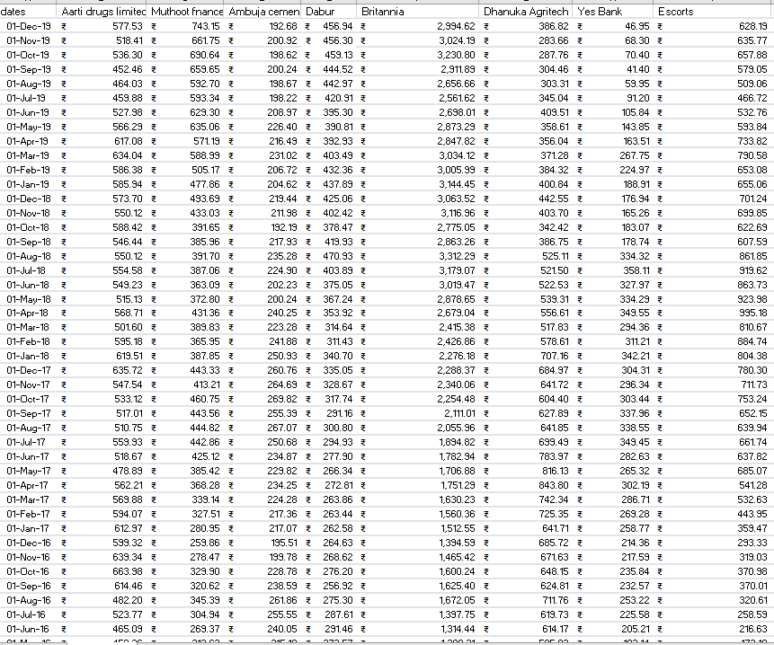

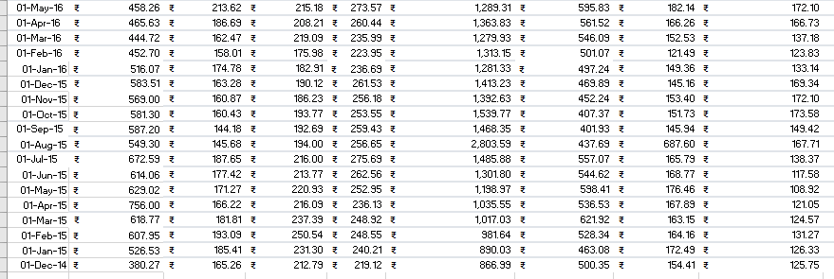

Monthly Returns for all 8 stocks from December 2014 to December 2019

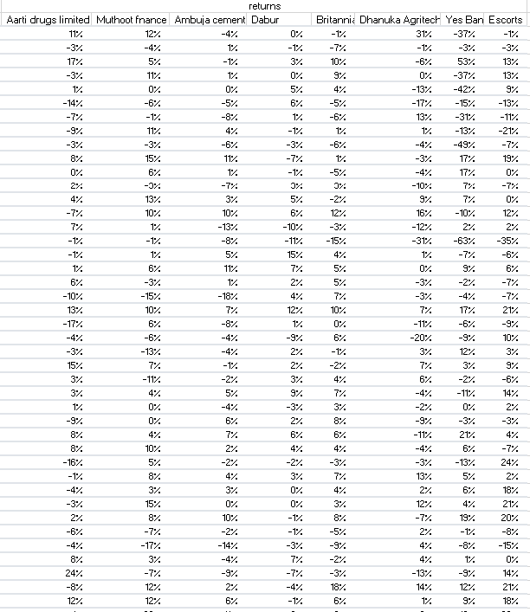

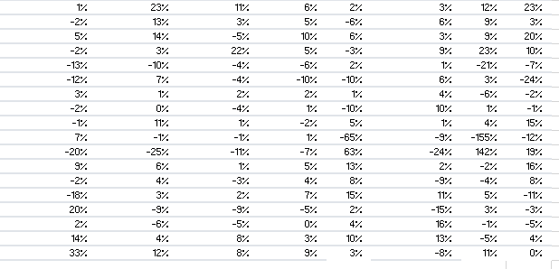

1. Markowitz, Harry. "Portfolio Selection." *The Journal of Finance*, vol. 7, no. 1, 1952, p. 77, www.math.ust.hk/~maykwok/courses/ma362/07F/markowitz_JF.pdf. Accessed 27 Aug. 2020.
2. Shane Van Dalsem. "Markowitz Portfolio Optimization." *YouTube*, Youtube, 11 Feb. 2011, www.youtube.com/watch?v=CNIVd_b7YJc. Accessed 1 Sept. 2020.
3. Chandra S Bhatnagar. "Global minimum variance 1: The Lagrangian function." *YouTube*, 6 Feb. 2010, www.youtube.com/watch?v=GEBCTa0wAkE. Accessed 14 Sept. 2020.